06.05
Aircraft Incidents
Process Design & AMOS Configuration Document
Purpose
This Process Design document is provided to Key-Users to record their key decisions regarding the AMOS Process design and the required AMOS configuration.
It is updated throughout the Project Definition Phase and used as the baseline for the Final Acceptance prior to Go-Live
Revision
Author, Name | Date | Notes
BENX | 28.05.2024 | First Version
FDEL & DEOS | 14.01.2025 | Revision 24.12

Table of Contents
1. Process Overview & Objectives 3
2. Regulatory References 3
3. Definitions & Glossary 3
4. Process Tasks 3
5. Process Dependencies 3
6. Process Flow 4
7. Process Design Questions 5
8. Data (Source) Mapping 6
9. Other Software Used 6
10. AMOS Configuration 7
a. Basic Data 7
b. Parameters 7
c. Workflows 7
d. Scheduled Tasks 7
e. API’s & Interfaces 7
11. Annex – Additional Info 8

Process Overview & Objectives

Process General Description:
The process contains two main flows:
- Occurrence Reporting:
Occurrence Reporting can be used as stand-alone application for technical department’s, or it is possible to send Technical Occurrence Reports to the company wide Safety Management department or system (SMS). The objective of the occurrence reporting, collection, analysis and investigation systems described in the operating and airworthiness rules, is to use the reported information to contribute to the improvement of aviation safety, and not to attribute blame, impose fines or take other enforcement actions. The occurrence reporting is a mandatory document that has to be written if specific events take place. It must be submitted internally and to the National Aviation Authority.

- Aircraft Incidents / Accidents:
To record, rectify and report (internal/external) Aircraft Incidents and to be sure that A/C data cannot be manipulated during investigation.

Main Process Objective (Outputs & Outcomes):
- Occurrence Reporting:
  - To enable an assessment of the safety implications of each occurrence to be made, including previous similar occurrences, so that any necessary action can be initiated. This includes determining what and why it had occurred and what might prevent a similar occurrence.
  - To ensure that knowledge of occurrences is disseminated so that other persons and organisations may learn from them.
  - Occurrences should remain in the database when judged reportable by the person submitting the report as the significance of such a report may only become obvious at a later date.
  - In addition to the requirement to notify the appropriate accident investigating authorities directly of any accident or serious incident, operators should also report to the national authority in charge of supervising the reporting organisation.

- Aircraft Incidents / Accidents:
To record, rectify and report (internal/external) Aircraft Incidents and to be sure that A/C data cannot be manipulated during investigation.

Regulatory References

The following regulatory references were identified for this process:
- EASA Part-CAMO – CAMO.A.155
- EASA Part-CAMO – CAMO.A.200
- EASA Part-CAMO – CAMO.A.202
- EASA Part-145 – 145.A.60

Definitions & Glossary

Key-Words | Explanation
Event | Every occurrence that is worthy to record in AMOS. Aircraft events (e.g. technical problem leading or not to operations interruption), or station events (e.g. hangar door got damage).
Consequence | Basically, a delay, cancellation, turn around, deviation.
Delay Code | A delay code is a unique number within an IATA numbering system, where a delay (technical or operational) can be classified.
SMS | Safety Management System
DFDR | Digital Flight Data Recorder
CVR | Cockpit Voice Recorder
Accident  (ICAO definition) | An occurrence associated with the operation of an aircraft which takes place between the time any person boards the aircraft with the intention of flight until such time as all such persons have disembarked, in which:  a) a person is fatally or seriously injured as a result of:  - being in the aircraft, or  - direct contact with any part of the aircraft, including parts which have become detached from the aircraft, or  - direct exposure to jet blast,  except when the injuries are from natural causes, self-inflicted or inflicted by other persons, or when the injuries are to stowaways hiding outside the areas normally available to the passengers and crew; or  b) the aircraft sustains damage or structural failure which:  - adversely affects the structural strength, performance or flight characteristics of the aircraft, and  - would normally require major repair or replacement of the affected component,  except for engine failure or damage, when the damage is limited to the engine, its cowlings or accessories; or for damage limited to propellers, wing tips, antennas, tires, brakes, fairings, small dents or puncture holes in the aircraft skin; or  c) the aircraft is missing or is completely inaccessible.  Note 1.: For statistical uniformity only, an injury resulting in death within thirty days of the date of the accident is classified as a fatal injury by ICAO.  Note 2.: An aircraft is considered to be missing when the official search has been terminated and the wreckage has not been located.
Incident  (ICAO definition) | An occurrence, other than an accident, associated with the operation of an aircraft which affects or could affect the safety of operation.  Note: The types of incidents which are of main interest to the International Civil Aviation Organization for accident prevention studies are listed in the Accident/Incident Reporting Manual (Doc 9156).
Serious incident  (ICAO definition) | An incident involving circumstances indicating that an accident nearly occurred.

Process Tasks

Business Process Task / Actions / Activities:
- Occurrence
  - Refer to process 06.02 – Delays & Event Tracking
  - After creating an event marked with occurrence create an occurrence in APN1313 and enter the occurrence number in the applicable event.
  - Fill in all necessary data in the occurrence report thereafter send the report to Safety Management System (SMS) and to the authority.

- Incident / Accident
  - Define if it’s an accident or incident under following definition:
    - Accident
      - An occurrence associated with the operation of an aircraft which takes place between the time any person boards the aircraft with the intention of flight until such a time that all such persons have disembarked, in which:
      - A person is fatally or seriously injured as a result of:
        - being in the aircraft, or
        - direct contact with any part of the aircraft, including parts which have become detached from the aircraft, or
        - direct exposure to jet blast,
      - except when the injuries are from natural causes, self inflicted or inflicted by other persons, or when the injuries are to stowaways hiding outside the areas normally available to the passengers and crew.
    - Incident
      - An occurrence, other than an accident, associated with the operation of an aircraft which affects or could affect the safety of operation.
  - Refer to process 06.02 – Delays & Event Tracking and create an aircraft event and select the tickbox for accident or incident.
  - Issue a Workorder for removal or retrieval Data of FDR , CVR or any other flight data recording device. This Workorder will be performed with Process 08.02 – Performing of Maintenance.
  - In APN 308 set Aircraft Status to “Under investigation” to make sure no data can be delete or manipulated.
  - The retrieved flight data will be handover from MCC to Quality. Quality must provide the Flight Data & Aircraft Technical Records to the authorities for further investigation.
  - When investigation is finished remove the Aircraft Status “Under Investigation” in APN308 to have a normal AC status at the end.
  - Inform the Flight OPS that the Aircraft is in normal operation.

Process Dependencies

INPUT | CONCURRENT | OUTPUT
 | 06.02 – Delays & Event Tracking  06.01 – Fleet Status Monitoring | 08.02 – Performing Maintenance  Aircraft Technical Records to Authority  Flight Data to Authority

Process Flow
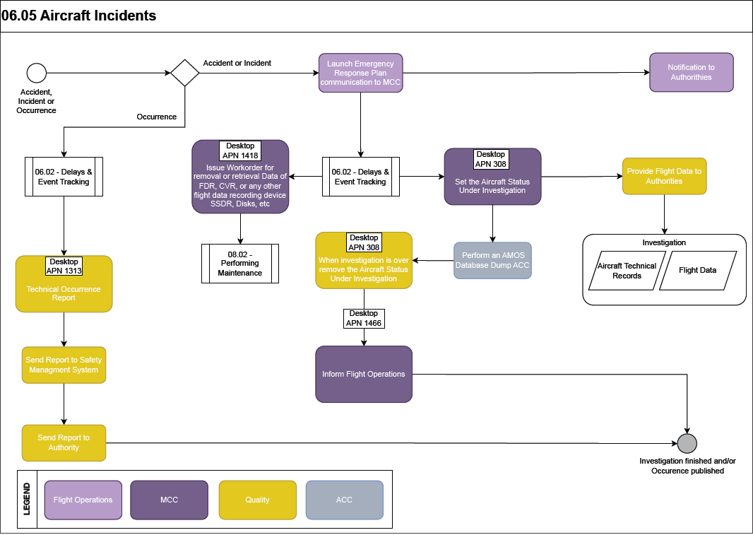

Process Design Questions

# | Question | Answer
1 | Will you use the Occurrence Reporting in AMOS? Or do you have a companywide SMS tool to cover even Flight Ops departments and crew?
2 | How is the event communicated to the quality department?  Will it be via Technical Assistance query (APN: 869)?  An external tool integrated to the SMS?
3 | Who issues the Occurrence Report? (QA department, Engineering department, MCC etc.)
4 | How are incidents reported to the Authorities (special report, special requirements for the report, etc.)?
5 | What is the general flow (minimum requirements) of information and where it is logged?
6 | Who is allowed to set the aircraft to an “under investigation status”? (Departments, etc.)
7 | How will the DFDR and CVR stored when needed for the investigation (inaccessible location, etc.)?

Data (Source) Mapping

Data Sources | Description | Volume / Manual / Automatic / Static / Dynamic
-Nil-

Other Software Used

Other Softwares | Used by: | Description
SMS | Quality | Safety Management System

AMOS Configuration

Basic Data

Basic Data Table | Notes
Occurrence Types (used in APN: 432) | To define additional Type off Occurrences
Accident Type | To define Incident/Accident types; used in application Occurrence Reporting
Consequence Type | To define Consequence types; used in application Occurrence Reporting
Occurrence Type | To define Occurrence types
Operation Phase | Defines the Flight Phases. Theses Phases are selectable in Event Tracking to specify in what Flight Phase a Problem Occurred.
Advice Classification | Whenever you set an Advise Time for an Event in Event Tracking you can assign it to an Classification (Incident or Accident as well). This can be used to filter the advise times in the "Upcoming Advise" view in the program.
Communication Types | When creating a new Event in program Event Tracking you can specify how you were informed.
Consequence Reason Groups | When entering a consequence in Event Tracking you have the possibility to classify the Delay / Cancellation like A/C Under Investigation.  Pleases note:  You have to specify a Group and a Type.
Consequence Reason Types | When entering a consequence in Event Tracking you have the possibility to classify the Delay / Cancellation like A/C Under Investigation.  Pleases note:  You have to specify a Group and a Type.
Event Groups | Every Event in Event Tracking can have an classification associated with Event Groups.  A classification consists of a Group and a Type.
Event Types | Every Event in Event Tracking can have an classification associated with Event Types. A classification consists of a Group and a Type.
Incident Types | Then marking an Event in Event Tracking as Incident you can specify an type from a drop down box.
OPS Consequence | The Events in Event Tracking can be marked as "OPS consequence". There you will find a drop-down box to select an consequence from.  Please note:  This drop-down box will only appear if you have at least on entry in this table.

Parameters

Parameter Code | Parameter Name | Notes
1544 | SHOW OCCURRENCE TYPE COMBO BOX INSTEAD OF OCCURRENCE NO FIELD (used in APN 432) | If the parameter`s String value is set to Y the Occurrence Type combo-box will appear in the Event Dialog.  The Data from the Occurrence Type combo-box has to be defined in the Basic Table Occurrence Types of the program Basic Data Administration (APN 18).  While setting this parameter to Y the Occurrence No Field will disappear.
1460 | ASSIGN GROUP MANDATORY | "Y": The system automatically selects the "assigned to" group. The group with the highest number of queries for the query type is chosen. The groups in drop down list is sorted in descending number of queries. The user can change the selected group manually.  "N": Default behaviour. There is no group preselected and the user can select one from the list.
1544 | SHOW OCCURRENCE TYPE COMBO BOX INSTEAD OF OCCURRENCE NO FIELD | If the parameter`s String value is set to Y the Occurrence Type combo-box will appear in the Event Dialog.

Workflows

Workflow Number | Workflow Name | Notes
56 | New Consequence Workflow | This workflow is triggered when a new consequence is saved for an event in Aircraft Event Tracking module. If a consequence entry is edited and saved this workflow is NOT triggered again
56 | Event saved Workflow | This workflow is triggered when an A/C Event is saved.

Scheduled Tasks

Scheduled Task Reference | Frequency | Notes
SATAstraUpdateService |  | amos.server.admin.scheduler.tasks.scheduled.  interfaces.SATAstraUpdateService
TechnicalAssistantQueryReminderService |  | amos.server.admin.scheduler.tasks.scheduled  .system.TechnicalAssistantQueryReminderService
AmosMailTaskDueCheck | Maximum once a day, as only days are considered in the due date check. | This scheduler task checks all tasks from AMOS Mail on the due date and sends a reminder to users that have tasks which are due within the next 5 days.

API’s & Interfaces

Reference | Direction | Trigger | Frequency
To export Occurrences via AIM Web-service | EXPORT OCCURRENCE
For MRO with CAMO responsibility: | EXPORT AC PER CUSTOMER
If AIMS is used as OPS system. Export Maintenance Event (Workpackage) information to the AIMS system. | EXPORT AIMS MAINTENANCE EVENTS
For MRO with CAMO responsibility: Export of the Maintenance Forecast entries. | EXPORT MAINTENANCE FORECAST
If NETLINE is used as OPS system. Export Workpackages from AMOS to NETLINE as Ground-Events. | EXPORT NETLINE GROUNDEVENT
Export occurrences | EXPORT OCCURRENCE
If SABRE is used as OPS system. Export Workpackages from AMOS to SABRE as Ground-Events. | EXPORT SABRE GROUNDEVENT
For MRO with CAMO responsibility: Exports planning information of Maintenance Events included in Workpackages. | EXPORT WORKPACKAGE EVENT PLANNING
For MRO with CAMO responsibility: Exports planning information of Workpackage. | EXPORT WORKPACKAGE PLANNING
Import of ACARS messages | IMPORT ACARS MESSAGE

Annex – Additional Info

-Nil-

